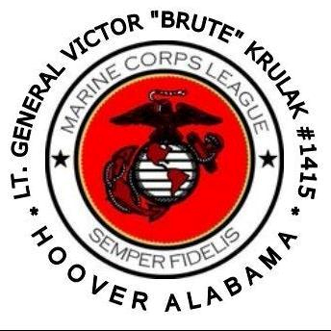

THE LT. GEN. VICTOR “BRUTE” KRULAK DETACHMENT
OF THE MARINE CORPS LEAGUE

Detachment Business Meeting Agenda

**Silence your PHONES

1000-1045: Call to Order/Attention on Deck/ Sr. Vice Commandant, Carol Higgins
- Posting of the Colors/Call Meeting to Order- Sergeant-of-Arms
- Invocation – John Simmons, Chaplain/Harvey Jones
- Recognize Guests and Visitors – Commandant, Fernando Valentin
- February Minutes – Commandant, Fernando Valentin
- Installation of New Adjutant – Robert Webb, Fernando Valentin
- Applicants for Membership – Judge Advocate, Ed Smith, Jr.
- New Member Ceremony – Sr. Vice Commandant, Carol Higgins
- Financial Report & 2017 Financial Review- Paymaster, Melody Lott

10:50-1100: For the Good of the Detachment
- Brute Auxiliary – Robin Schafer
- Boy Scouts – Don Brooks
- Brute Scholarship Program – Don Lehman
- 2018 Quarterly Raffles
- 2019 State Convention
- SWTB – David Landier
- Veterans Day Parade
- Membership & Retention – Jr Vice Commandant Mike Jeffries
- Brute Bash “Picnic”
- Detachment Survey

1105-1120: Monthly Donation Drawing

1125-1145: Retire Colors/Marine Corps Hymn, Jeff Bacon, Sergeant – at- Arms
- Benediction/ John Simmons, Chaplain/Harvey Jones
- Moment of Silence for Fallen Comrades/ Don Brooks, Taps
- Marine Corps Hymn/Sergeant – At- Arms
- Retire Colors/ Close

NEXT DETACHMENT MEETING/14 April 2018

