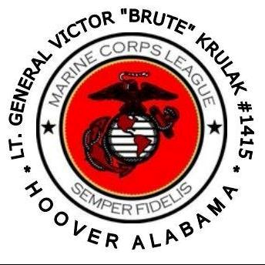

THE LT. GEN. VICTOR “BRUTE” KRULAK DETACHMENT
OF THE MARINE CORPS LEAGUE

Detachment Business Meeting Agenda

**Silence your PHONES

1000-1045: Call to Order/Attention on Deck/ Role Call - Sr. Vice Commandant, Carol Higgins
- Posting of the Colors/Call Meeting to Order- Sergeant-of-Arms
- Invocation – John Simmons, Chaplain/Harvey Jones
- Recognize Guests and Visitors – Commandant, Fernando Valentin
- Jan-April Minutes – Commandant, Fernando Valentin
- Applicants for Membership – Judge Advocate, Ed Smith, Jr.
- New Member Ceremony – Sr. Vice Commandant, Carol Higgins
- Financial Review- Paymaster, Melody Lott

10:50-1100: For the Good of the Detachment
- Guest Speaker – Mark Hamilton, Home Depot
- Boy Scouts – Sr. Vice Commandant, Carol Higgins
- Detachment Calendar of Events – Adjutant, Jessica Findley
- Upcoming Event Committees – Commandant, Fernando Valentin
- 2018 Dept. of Alabama Convention – Commandant, Fernando Valentin
  - Budget
  - TAG Fund
- 2019 State Convention – Adjutant, Jessica Findley
- SWTB – David Landier
- Marine/Associate of the Year, Commandant, Fernando Valentin
- Membership & Retention – Jr Vice Commandant Mike Jeffries

1105-1120: Monthly Donation Drawing

1125-1145: Retire Colors/Marine Corps Hymn, Jeff Bacon, Sergeant – at- Arms
- Benediction/ John Simmons, Chaplain/Harvey Jones
- Moment of Silence for Fallen Comrades/ Don Brooks, Taps
- Marine Corps Hymn/Sergeant – At- Arms
- Retire Colors/ Close

NEXT DETACHMENT MEETING/14 July 2018

- BYLAWS –

ARTICLE IV / PURPOSE
The purposes of the Lt. General Victor “Brute” Krulak Detachment shall be to:

- Band together current and honorably discharged/retired Marines, Fleet Marine Force Corpsmen, and Navy Chaplains in faithful camaraderie.
- Preserve the traditions and promote the interests of the United States Marine Corps.
- Effectively promote the ideals of American freedom and democracy.
- Fit its members for duties of citizenship and community service, and to encourage them to serve as ably as citizens as they have served the nation under arms.
- Hold sacred the history and memory of the men and women who have given their lives for the nation.
- Foster love for the principles they have supported by blood and valor since the founding of the Republic.
- Maintain true allegiance to American institutions.
- Create a bond of faithful comradeship between those in the service and those who have honorably returned to civilian life.
- Aid voluntarily and to render assistance to all current and former Marines, FMF Corpsmen, and Navy Chaplains, as well as to their spouses, children, orphans, and parents.
- Perpetuate the history of the United States Marine Corps, and by fitting acts to observe the anniversaries of historical occasions of particular interest to Marines, FMF Corpsmen, and Navy Chaplains.

- Business Meeting Protocol –

- Members must wear their Marine Corps League red cover during meetings.
- Members (regular and associates) must salute and be recognized by the Commandant prior to addressing the membership.
- During a meeting, a member wishing to leave the meeting, must first salute the U.S. flag prior to departing.
- Upon re-entering an active meeting, members (under cover) must salute the U.S. flag prior to being seated.

